CS 312 Computer Architecture II Name: George Kim
Lab 1. The AND, OR, NAND and NOR logic gates.

Use the Multimedia Logic system to set up the following circuit: F = AB + CD
Use four switches for controlling the inputs and an LED to show the value of R.
When you are asked to write the equation for the circuit, base the equation on the circuit diagram and not on the Truth Table.

1. Simulate the circuit for all combinations of A, B, C, and D and record the results. Use a truth table to show these results.

A | B | C | D | F
0 | 0 | 0 | 0 | 0
0 | 0 | 0 | 1 | 0
0 | 0 | 1 | 0 | 0
0 | 0 | 1 | 1 | 1
0 | 1 | 0 | 0 | 0
0 | 1 | 0 | 1 | 0
0 | 1 | 1 | 0 | 0
0 | 1 | 1 | 1 | 1
1 | 0 | 0 | 0 | 0
1 | 0 | 0 | 1 | 0
1 | 0 | 1 | 0 | 0
1 | 0 | 1 | 1 | 1
1 | 1 | 0 | 0 | 1
1 | 1 | 0 | 1 | 1
1 | 1 | 1 | 0 | 1
1 | 1 | 1 | 1 | 1


A –

B -



LED – (F)
C –

D -

2. Change the OR gate to a NOR gate. Simulate the circuit and record the results in a truth table.

Paste a screenshot of the circuit.
A | B | C | D | F
0 | 0 | 0 | 0 | 1
0 | 0 | 0 | 1 | 1
0 | 0 | 1 | 0 | 1
0 | 0 | 1 | 1 | 0
0 | 1 | 0 | 0 | 1
0 | 1 | 0 | 1 | 1
0 | 1 | 1 | 0 | 1
0 | 1 | 1 | 1 | 0
1 | 0 | 0 | 0 | 1
1 | 0 | 0 | 1 | 1
1 | 0 | 1 | 0 | 1
1 | 0 | 1 | 1 | 0
1 | 1 | 0 | 0 | 0
1 | 1 | 0 | 1 | 0
1 | 1 | 1 | 0 | 0
1 | 1 | 1 | 1 | 0

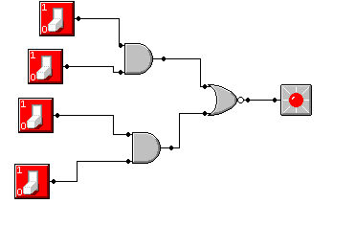

Write the equation for this circuit.

F=AB NOR CD

Apply DeMorgan’s Theorem to this equation and apply again until you get a product of sums. Expand the product of sums to get the sum of products equation.

F=not (AB) * not(CD)
F= (notA * notC) + (notA * notD) + (notB * notC) + (notB * notD)

3. Restore the OR gate and change the first AND gate to a NAND gate. Simulate the circuit and record the results in a truth table.
Paste a screenshot of the circuit.
A | B | C | D | F
0 | 0 | 0 | 0 | 1
0 | 0 | 0 | 1 | 1
0 | 0 | 1 | 0 | 1
0 | 0 | 1 | 1 | 0
0 | 1 | 0 | 0 | 1
0 | 1 | 0 | 1 | 1
0 | 1 | 1 | 0 | 1
0 | 1 | 1 | 1 | 0
1 | 0 | 0 | 0 | 1
1 | 0 | 0 | 1 | 1
1 | 0 | 1 | 0 | 1
1 | 0 | 1 | 1 | 0
1 | 1 | 0 | 0 | 1
1 | 1 | 0 | 1 | 1
1 | 1 | 1 | 0 | 1
1 | 1 | 1 | 1 | 1
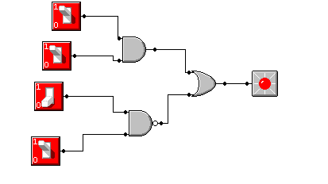

Write the equation for this circuit.

F=AB + not(CD)

Apply DeMorgan’s Theorem to this equation.

F=(AB)+ notC + notD

4. Set up both AND gates to be NAND gates. Simulate the circuit and record the results in a truth table.

Paste a screenshot of the circuit.
A | B | C | D | F
0 | 0 | 0 | 0 | 1
0 | 0 | 0 | 1 | 1
0 | 0 | 1 | 0 | 1
0 | 0 | 1 | 1 | 1
0 | 1 | 0 | 0 | 1
0 | 1 | 0 | 1 | 1
0 | 1 | 1 | 0 | 1
0 | 1 | 1 | 1 | 1
1 | 0 | 0 | 0 | 1
1 | 0 | 0 | 1 | 1
1 | 0 | 1 | 0 | 1
1 | 0 | 1 | 1 | 1
1 | 1 | 0 | 0 | 1
1 | 1 | 0 | 1 | 1
1 | 1 | 1 | 0 | 1
1 | 1 | 1 | 1 | 0
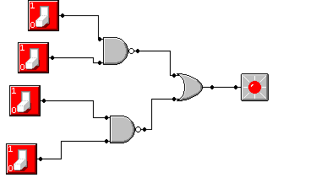

Write the equation for this circuit.

F=not(AB)+not(CD)

Apply DeMorgan’s Theorem to this equation.

F=notA + notB + notC + notD
5. Change the OR gate to NOR gate. Simulate the circuit and record the results in a truth table.

Paste a screenshot of the circuit.
A | B | C | D | F
0 | 0 | 0 | 0 | 0
0 | 0 | 0 | 1 | 0
0 | 0 | 1 | 0 | 0
0 | 0 | 1 | 1 | 0
0 | 1 | 0 | 0 | 0
0 | 1 | 0 | 1 | 0
0 | 1 | 1 | 0 | 0
0 | 1 | 1 | 1 | 0
1 | 0 | 0 | 0 | 0
1 | 0 | 0 | 1 | 0
1 | 0 | 1 | 0 | 0
1 | 0 | 1 | 1 | 0
1 | 1 | 0 | 0 | 0
1 | 1 | 0 | 1 | 0
1 | 1 | 1 | 0 | 0
1 | 1 | 1 | 1 | 1
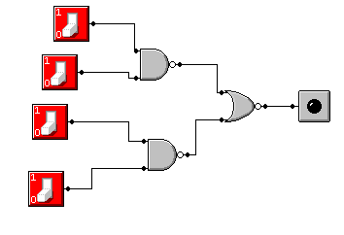

Write the equation for this circuit.

F=not(AB) NOR not(CD)

Apply DeMorgan’s Theorem to this equation until it is in the simplest state.

F=AB * CD
F=ABCD

